Exercitii liste examen

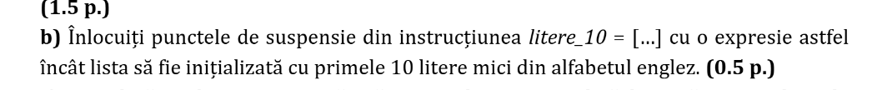
1.

litere_10 = [chr(ord('a') + i) for i in range(10)]

ord('a') obține codul numeric (ASCII/Unicode) al literei 'a' (care este 97)

2.
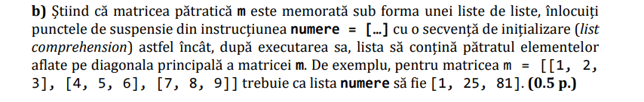
numere = [m[i][i] ** 2 for i in range(len(m))]

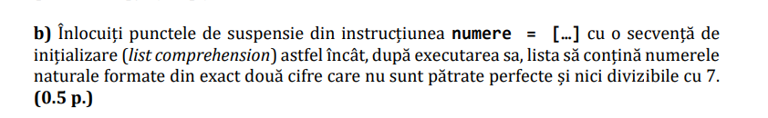
3.

numere = [x for x in range(10, 100) if int(x**0.5) ** 2 != x and x % 7 != 0]

4.
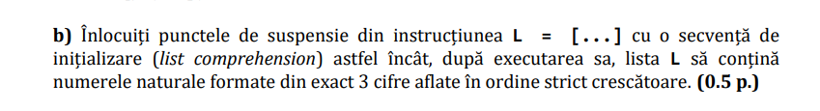
L = [n for n in range(100, 1000) if str(n)[0] < str(n)[1] < str(n)[2]]

5.
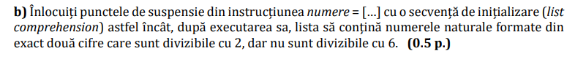

numere = [x for x in range(10, 100) if x % 2 == 0 and x % 6 != 0]

6.
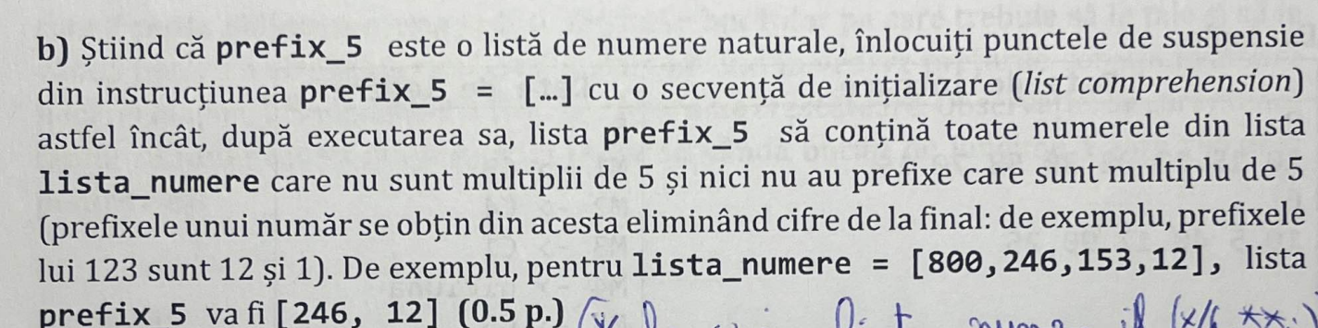

prefix_5 = [n for n in lista_numere if n % 5 != 0 and len([p for p in [n // (10**i) for i in range(1, len(str(n)))] if p % 5 == 0]) == 0]

